

|  |
| --- |
| INTEL-Unnati Project: FakeNews |
|  |
| July 15  NITTE Meenakshi Institute Of Technology  Authored by: Team Trailblazers |



# In-Depth Exploratory Data Analysis:

# About Dataset:

# A blue and orange rectangular bars Description automatically generatedA graph of different colored bars Description automatically generatedOur dataset consists of only a few domains of news and thus is not guaranteed of giving the best performance for news from different domains. And the distribution of news across different domains is as follows:

# As we can see here that only Fake news has 6 different domains while True file has news divided only into 2 domains.

# A close up of words Description automatically generatedThe WordCloud is shown below and it describes the most repeated words in both files:

Fake Data

True Data

|  |
| --- |
| **Machine Learning Model (Using Fake AI-Generated Data):** Split Of Data between Real and Fake News Files  Our Machine Learning model is consisting of the classification of fake news between human-authored fake news, real news and AI-generated fake news. Further we’ve done a two way classification between them and the results are displayed as follows: |
| These represent the ROC-AUC curve and the Precision-Recall curves respectively and as we can see even though our Accuracy was quite good the results didn’t converge up to the mark. |
| **Deep Learning Models:**  A graph of a graph with blue and orange lines  Description automatically generatedThe best performance was obtained by training our LSTM model with the layers specified below and using Glove Embeddings and the evaluation metric have been plotted:  A diagram of a data flow  Description automatically generatedA graph of a curve  Description automatically generated  ROC Curve  Loss v/s Epochs  Accuracy v/s Epochs |

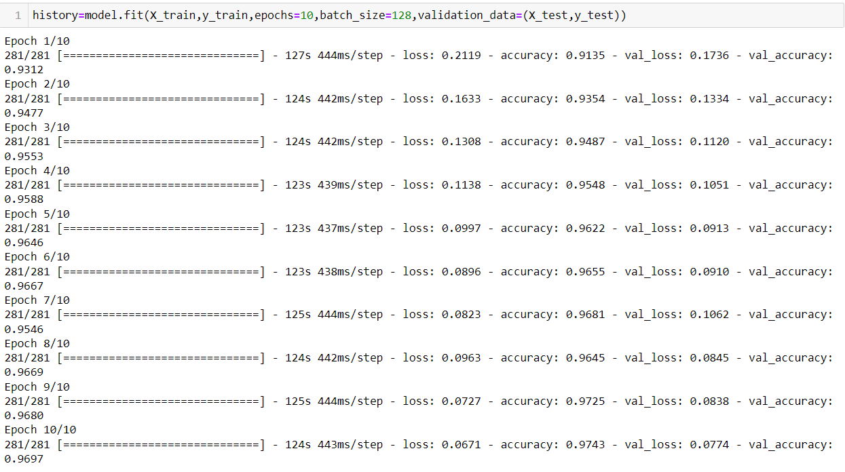The results of training and the confusion matrix has been shown below:

CONFUSION MATRIX

Even though we had a very good accuracy on our deep learning models the only problem was that of generalization and to solve it we needed too much data in order to make our machine learn human semantics of Natural Language and thus we came to the point of choosing transformer-based models and hence experimented on BERT, RoBERTa and DistilBERT. And were successful only in verifying results from our model built upon the BERT Architecture due to the assigned timeframe. Still other results have also been displayed below:

BERT:

Our training accuracy was about 90% and the confusion matrix is represented here. Even though our accuracy was not as good as our deep learning model, it outperformed all our previous models in classifying real-world news titles as fake or true.

* We just used the complete pre-trained model in this case and didn’t use any of the word embeddings except tokenizing the sentences using BertTokenizer.

CONFUSION MATRIX

BERT with TF-IDF Vectorizer:

Now moving forward we apply one of the mostly used embedding techniques i.e Tf-idf Vectorizer and thus our results are highly improved still without having any additional layers on top of the BERT Architecture.

* Even while training on a single epoch(due to time constraints) we were able to get a very high accuracy of 93.59% and could have easily increased if allowed to be trained on 5-10 epochs.



